Introduction to Data Science

Homework # 3

Question # 2

1. Importing the libraries

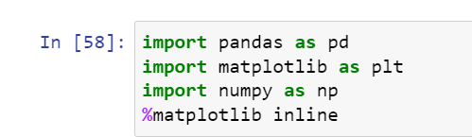

1. Reading a CSV file



1. Overviewing the data in the file using head()

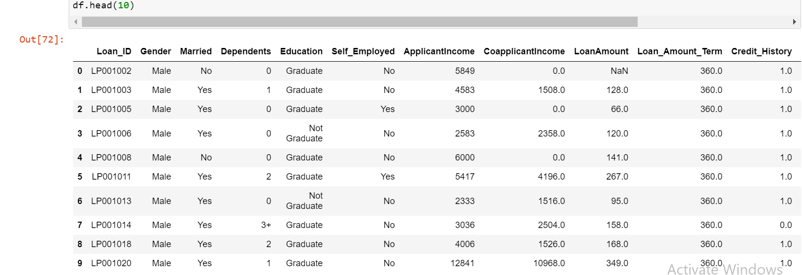

1. Describing the data

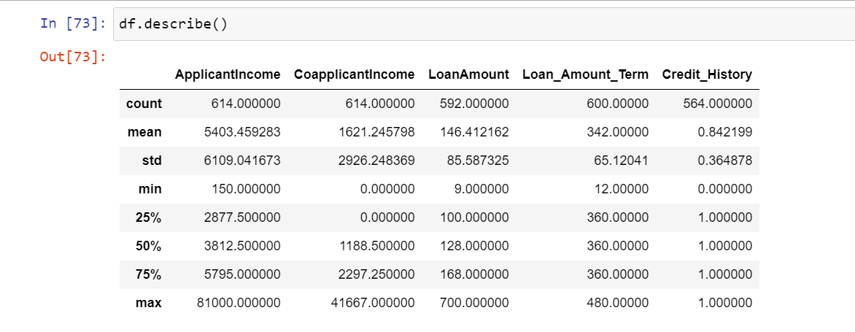

1. Value Counts

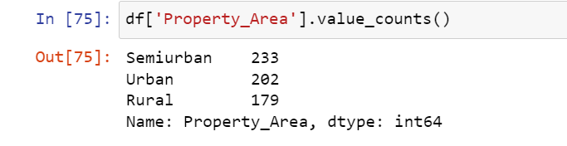

1. Histogram of a specific column

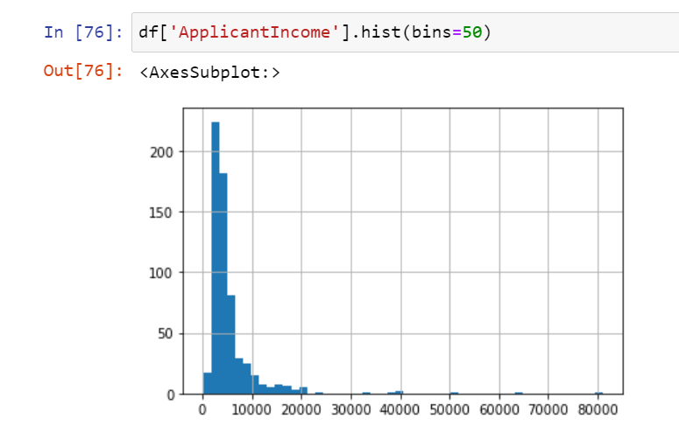

1. Box and Whisker Plot

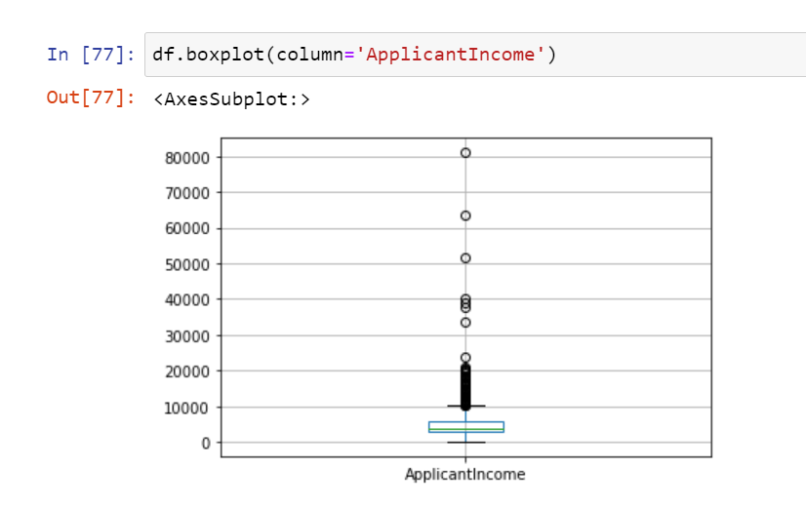

1. Bar Graphs

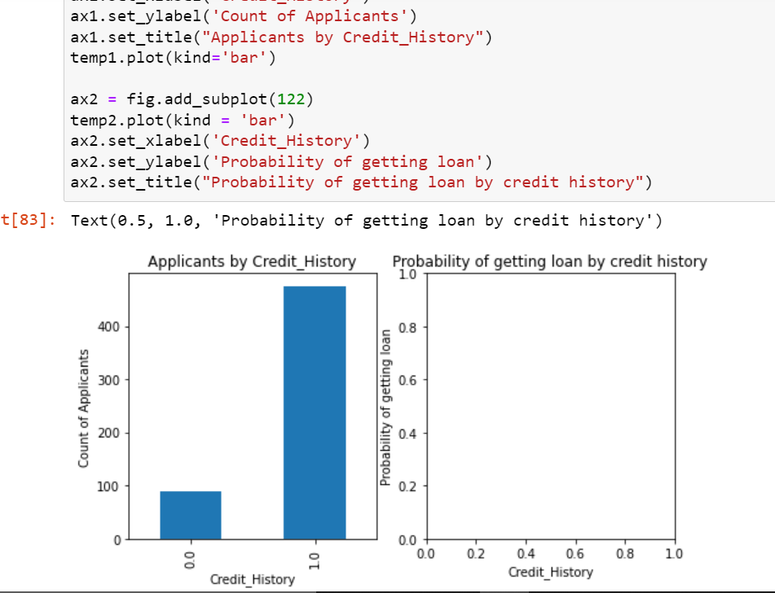

1. In comparison Bar graphs

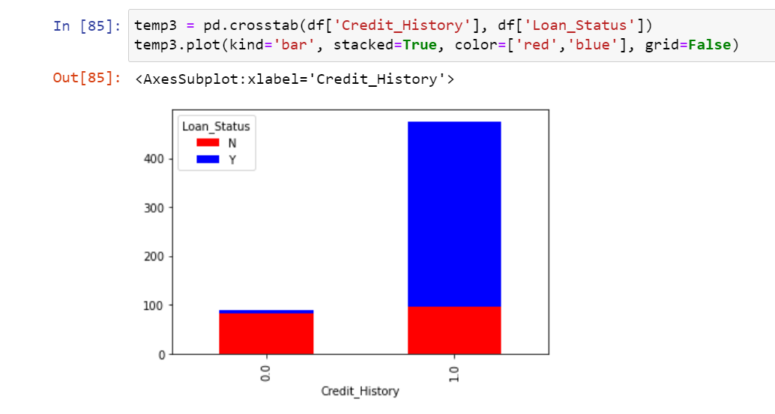

1. Training Models

